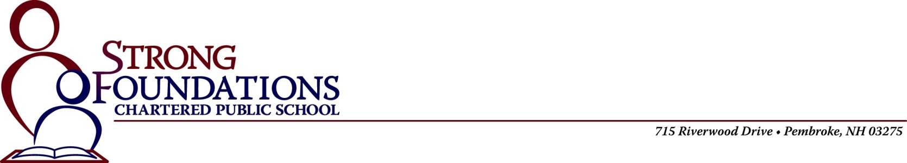

Application for Admission 2025-2026
Application Timeline and Process: We are currently accepting applications for the 2025-2026 school year. Our open enrollment period for the lottery is from January 1, 2025 through March 31, 2025. We accept applications after March 31st, and those will be placed on a waitlist. If more students apply than Strong Foundations can accept, then a lottery will be conducted for the spaces. Students not selected by lottery but wishing to attend will be placed on a wait list. For any openings that become available, students on the wait list will have first choice. Applications are being accepted for Kindergarten (age 5 by September 30, 2025) and Grades One, Two, Three, Four, Five, Six, Seven and Eight.

Student’s Name:__________________________________________________________________________________________
First Middle Last
Preferred / Nickname:__________________ Male Female

Date of Birth:_____________________
Month Day Year

Current Grade as of September 2024:_______________ Applying for: K 1 2 3 4 5 6 7 8 (circle one)

Current School Name:______________________________________________________________________

Address:___________________________________________________________________________________________________

Parent / Legal Guardian 1 Parent / Legal Guardian 2
Name: ___________________________ __________________________

Home Address: ___________________________ __________________________

___________________________ __________________________

Home Phone: ___________________________ __________________________

Cell Phone: ___________________________ __________________________

E-mail Address: ___________________________ __________________________

How did you hear about our school? _________________________________________________

Parent / Guardian 1 Signature:___________________________________ Date:_____________

Parent / Guardian 2 Signature:___________________________________ Date:_____________

Please return this completed application and all other paperwork to “Strong Foundations Admissions” at the address above.

